第九章 对应方法分析

一、授予博士学位的数目

1、美国与1973年到1978年授予哲学博士学位的数目

| **Obs** | **x1** | **x2** | **x3** | **x4** | **x5** | **x6** |
| --- | --- | --- | --- | --- | --- | --- |
| **1** | 4489 | 4303 | 4402 | 4350 | 4266 | 4361 |
| **2** | 4101 | 3800 | 3749 | 3572 | 3410 | 3234 |
| **3** | 3354 | 3286 | 3344 | 3278 | 3137 | 3008 |
| **4** | 2444 | 2587 | 2749 | 2878 | 2960 | 3049 |
| **5** | 3338 | 3144 | 2959 | 2791 | 2641 | 2432 |
| **6** | 1222 | 1196 | 1149 | 1003 | 959 | 959 |

其中，1到6依次为生命科学、物理学、社会学、行为科学、工程学、数学。

X1到x6依次为1973,1974，1975,1976,1977,1978.

2、SAS程序

data chapter9;

input x1 x2 x3 x4 x5 x6 ;

cards;

4489 4303 4402 4350 4266 4361

4101 3800 3749 3572 3410 3234

3354 3286 3344 3278 3137 3008

2444 2587 2749 2878 2960 3049

3338 3144 2959 2791 2641 2432

1222 1196 1149 1003 959 959

;

proc print;

run;

proc corresp out=results;

var x1 x2 x3 x4 x5 x6;

run;

3、结果分析

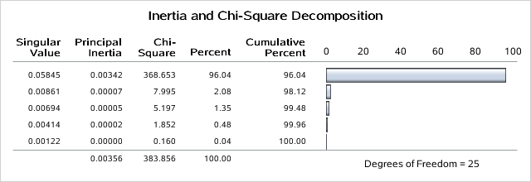

这张表给出了总卡方统计量等于383.863.

Singular value是奇异值分解

Principal inertia 表示惯量主值

由于总卡方的百分之96.04是由第一维说明，他表示行点和列点的关系用一维说明就可以了。

| **Row Coordinates** | | |
| --- | --- | --- |
|  | **Dim1** | **Dim2** |
| **Row1** | 0.0258 | 0.0081 |
| **Row2** | -0.0413 | -0.0024 |
| **Row3** | 0.0014 | -0.0114 |
| **Row4** | 0.1100 | -0.0013 |
| **Row5** | -0.0704 | -0.0037 |
| **Row6** | -0.0639 | 0.0228 |

| **Summary Statistics for the Row Points** | | | |
| --- | --- | --- | --- |
|  | **Quality** | **Mass** | **Inertia** |
| **Row1** | 0.9297 | 0.2425 | 0.0537 |
| **Row2** | 0.9771 | 0.2026 | 0.0997 |
| **Row3** | 0.6711 | 0.1799 | 0.0100 |
| **Row4** | 0.9970 | 0.1545 | 0.5271 |
| **Row5** | 0.9899 | 0.1604 | 0.2262 |
| **Row6** | 0.9331 | 0.0601 | 0.0834 |

| **Partial Contributions to Inertia for the Row Points** | | |
| --- | --- | --- |
|  | **Dim1** | **Dim2** |
| **Row1** | 0.0473 | 0.2146 |
| **Row2** | 0.1010 | 0.0160 |
| **Row3** | 0.0001 | 0.3162 |
| **Row4** | 0.5471 | 0.0035 |
| **Row5** | 0.2325 | 0.0292 |
| **Row6** | 0.0720 | 0.4205 |

| **Indices of the Coordinates That Contribute Most to Inertia for the Row Points** | | | |
| --- | --- | --- | --- |
|  | **Dim1** | **Dim2** | **Best** |
| **Row1** | 0 | 2 | 2 |
| **Row2** | 1 | 0 | 1 |
| **Row3** | 0 | 2 | 2 |
| **Row4** | 1 | 0 | 1 |
| **Row5** | 1 | 0 | 1 |
| **Row6** | 0 | 2 | 2 |

| **Squared Cosines for the Row Points** | | |
| --- | --- | --- |
|  | **Dim1** | **Dim2** |
| **Row1** | 0.8464 | 0.0833 |
| **Row2** | 0.9737 | 0.0033 |
| **Row3** | 0.0093 | 0.6618 |
| **Row4** | 0.9968 | 0.0001 |
| **Row5** | 0.9873 | 0.0027 |
| **Row6** | 0.8282 | 0.1050 |

这些是行坐标的输出结果，dim1表示了6门学科的变化方向。

| **Column Coordinates** | | |
| --- | --- | --- |
|  | **Dim1** | **Dim2** |
| **x1** | -0.0840 | 0.0033 |
| **x2** | -0.0509 | 0.0029 |
| **x3** | -0.0148 | 0.0008 |
| **x4** | 0.0242 | -0.0129 |
| **x5** | 0.0512 | -0.0082 |
| **x6** | 0.0864 | 0.0143 |

| **Summary Statistics for the Column Points** | | | |
| --- | --- | --- | --- |
|  | **Quality** | **Mass** | **Inertia** |
| **x1** | 0.9837 | 0.1756 | 0.3548 |
| **x2** | 0.9541 | 0.1697 | 0.1300 |
| **x3** | 0.6846 | 0.1701 | 0.0154 |
| **x4** | 0.9819 | 0.1656 | 0.0358 |
| **x5** | 0.9904 | 0.1610 | 0.1231 |
| **x6** | 0.9990 | 0.1579 | 0.3409 |

| **Partial Contributions to Inertia for the Column Points** | | |
| --- | --- | --- |
|  | **Dim1** | **Dim2** |
| **x1** | 0.3629 | 0.0251 |
| **x2** | 0.1287 | 0.0198 |
| **x3** | 0.0109 | 0.0014 |
| **x4** | 0.0285 | 0.3735 |
| **x5** | 0.1238 | 0.1458 |
| **x6** | 0.3452 | 0.4345 |

| **Indices of the Coordinates That Contribute Most to Inertia for the Column Points** | | | |
| --- | --- | --- | --- |
|  | **Dim1** | **Dim2** | **Best** |
| **x1** | 1 | 0 | 1 |
| **x2** | 1 | 0 | 1 |
| **x3** | 0 | 0 | 1 |
| **x4** | 0 | 2 | 2 |
| **x5** | 0 | 0 | 2 |
| **x6** | 2 | 2 | 2 |

| **Squared Cosines for the Column Points** | | |
| --- | --- | --- |
|  | **Dim1** | **Dim2** |
| **x1** | 0.9822 | 0.0015 |
| **x2** | 0.9509 | 0.0032 |
| **x3** | 0.6826 | 0.0020 |
| **x4** | 0.7645 | 0.2174 |
| **x5** | 0.9658 | 0.0247 |
| **x6** | 0.9724 | 0.0265 |

这是列坐标的输出结果。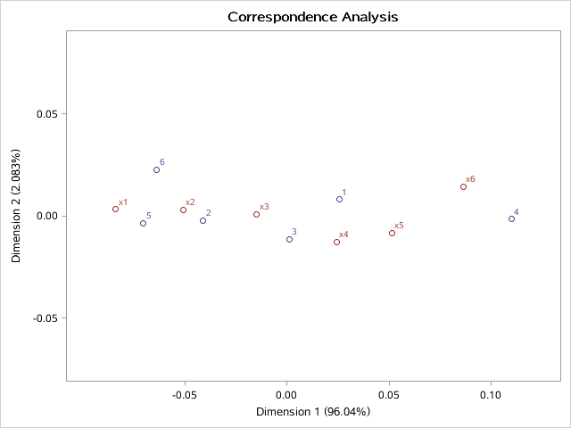

行和列的散点图。

二、我国部分省份农村居民的消费结构

1、中国10个省份农村居民家庭人均消费支出结构

| **Obs** | **A** | **B** | **C** | **D** | **E** | **F** | **G** |
| --- | --- | --- | --- | --- | --- | --- | --- |
| **1** | 0.58391 | 0.11148 | 0.09247 | 0.050073 | 0.038193 | 0.018803 | 0.079946 |
| **2** | 0.58122 | 0.08132 | 0.11238 | 0.042396 | 0.043280 | 0.040004 | 0.083339 |
| **3** | 0.56504 | 0.10012 | 0.12397 | 0.041121 | 0.043429 | 0.031328 | 0.078919 |
| **4** | 0.53092 | 0.10531 | 0.11695 | 0.045064 | 0.043735 | 0.038508 | 0.095256 |
| **5** | 0.55520 | 0.09650 | 0.14350 | 0.037566 | 0.052111 | 0.026267 | 0.072829 |
| **6** | 0.65495 | 0.04785 | 0.09524 | 0.047945 | 0.022134 | 0.018519 | 0.096844 |
| **7** | 0.64001 | 0.06168 | 0.11668 | 0.048471 | 0.033529 | 0.017439 | 0.072043 |
| **8** | 0.72524 | 0.05636 | 0.07326 | 0.044388 | 0.016366 | 0.015720 | 0.057261 |
| **9** | 0.67863 | 0.05804 | 0.08832 | 0.038100 | 0.039794 | 0.015167 | 0.067999 |
| **10** | 0.66591 | 0.08851 | 0.09690 | 0.038191 | 0.039275 | 0.019243 | 0.033801 |

其中1到10依次为山西、内蒙古、辽宁、吉林、黑龙江、河南、四川、贵州、甘肃、青海。

2、SAS程序

data chapter9;

input A B C D E F G;

cards;

0.583910 0.111480 0.092473 0.050073 0.038193 0.018803 0.079946

0.581218 0.081315 0.112380 0.042396 0.043280 0.040004 0.083339

0.565036 0.100121 0.123970 0.041121 0.043429 0.031328 0.078919

0.530918 0.105306 0.116952 0.045064 0.043735 0.038508 0.095256

0.555201 0.096500 0.143498 0.037566 0.052111 0.026267 0.072829

0.654952 0.047852 0.095238 0.047945 0.022134 0.018519 0.096844

0.640012 0.061680 0.116677 0.048471 0.033529 0.017439 0.072043

0.725239 0.056362 0.073262 0.044388 0.016366 0.015720 0.057261

0.678630 0.058043 0.088316 0.038100 0.039794 0.015167 0.067999

0.665913 0.088508 0.096899 0.038191 0.039275 0.019243 0.033801

;

proc print;

run;

proc corresp out=result;

var A B C D E F G;

run;

3、结果分析

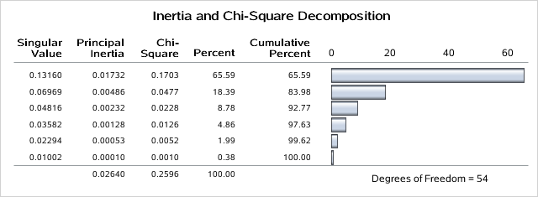

这张表给出了惯量和卡方分解，由表可知总卡方等于0.2596，由于18.39+65.59=83.98，所以这张表用二维表示就可以了。

| **Row Coordinates** | | |
| --- | --- | --- |
|  | **Dim1** | **Dim2** |
| **Row1** | 0.0581 | -0.0281 |
| **Row2** | 0.0910 | 0.0421 |
| **Row3** | 0.1257 | -0.0100 |
| **Row4** | 0.1838 | 0.0471 |
| **Row5** | 0.1476 | -0.0414 |
| **Row6** | -0.1171 | 0.1344 |
| **Row7** | -0.0603 | 0.0235 |
| **Row8** | -0.2276 | -0.0069 |
| **Row9** | -0.1247 | -0.0082 |
| **Row10** | -0.0730 | -0.1526 |

| **Summary Statistics for the Row Points** | | | |
| --- | --- | --- | --- |
|  | **Quality** | **Mass** | **Inertia** |
| **Row1** | 0.2239 | 0.0992 | 0.0700 |
| **Row2** | 0.6457 | 0.1001 | 0.0590 |
| **Row3** | 0.9808 | 0.1001 | 0.0614 |
| **Row4** | 0.9445 | 0.0992 | 0.1433 |
| **Row5** | 0.7780 | 0.1001 | 0.1145 |
| **Row6** | 0.9853 | 0.1000 | 0.1221 |
| **Row7** | 0.4559 | 0.1007 | 0.0350 |
| **Row8** | 0.9492 | 0.1005 | 0.2080 |
| **Row9** | 0.7795 | 0.1003 | 0.0761 |
| **Row10** | 0.9802 | 0.0999 | 0.1104 |

| **Partial Contributions to Inertia for the Row Points** | | |
| --- | --- | --- |
|  | **Dim1** | **Dim2** |
| **Row1** | 0.0194 | 0.0162 |
| **Row2** | 0.0479 | 0.0365 |
| **Row3** | 0.0913 | 0.0021 |
| **Row4** | 0.1937 | 0.0454 |
| **Row5** | 0.1259 | 0.0353 |
| **Row6** | 0.0792 | 0.3719 |
| **Row7** | 0.0212 | 0.0114 |
| **Row8** | 0.3007 | 0.0010 |
| **Row9** | 0.0901 | 0.0014 |
| **Row10** | 0.0307 | 0.4789 |

| **Indices of the Coordinates That Contribute Most to Inertia for the Row Points** | | | |
| --- | --- | --- | --- |
|  | **Dim1** | **Dim2** | **Best** |
| **Row1** | 0 | 0 | 1 |
| **Row2** | 0 | 0 | 1 |
| **Row3** | 1 | 0 | 1 |
| **Row4** | 1 | 0 | 1 |
| **Row5** | 1 | 0 | 1 |
| **Row6** | 0 | 2 | 2 |
| **Row7** | 0 | 0 | 1 |
| **Row8** | 1 | 0 | 1 |
| **Row9** | 1 | 0 | 1 |
| **Row10** | 0 | 2 | 2 |

| **Squared Cosines for the Row Points** | | |
| --- | --- | --- |
|  | **Dim1** | **Dim2** |
| **Row1** | 0.1814 | 0.0425 |
| **Row2** | 0.5320 | 0.1137 |
| **Row3** | 0.9746 | 0.0062 |
| **Row4** | 0.8862 | 0.0583 |
| **Row5** | 0.7212 | 0.0568 |
| **Row6** | 0.4254 | 0.5600 |
| **Row7** | 0.3960 | 0.0599 |
| **Row8** | 0.9483 | 0.0009 |
| **Row9** | 0.7761 | 0.0034 |
| **Row10** | 0.1826 | 0.79 |

这是行坐标的输出结果，由图可知，第一维中row1row2row3row4row5逐渐增加，其他逐渐减少。

| **Column Coordinates** | | |
| --- | --- | --- |
|  | **Dim1** | **Dim2** |
| **A** | -0.0937 | -0.0111 |
| **B** | 0.2280 | -0.1110 |
| **C** | 0.1500 | -0.0004 |
| **D** | -0.0072 | 0.0551 |
| **E** | 0.2285 | -0.0948 |
| **F** | 0.3006 | 0.0772 |
| **G** | 0.1106 | 0.2047 |

| **Summary Statistics for the Column Points** | | | |
| --- | --- | --- | --- |
|  | **Quality** | **Mass** | **Inertia** |
| **A** | 0.9952 | 0.6286 | 0.2128 |
| **B** | 0.8519 | 0.0821 | 0.2347 |
| **C** | 0.6682 | 0.1078 | 0.1374 |
| **D** | 0.2985 | 0.0441 | 0.0173 |
| **E** | 0.8150 | 0.0378 | 0.1076 |
| **F** | 0.6966 | 0.0245 | 0.1284 |
| **G** | 0.9517 | 0.0751 | 0.1618 |

| **Partial Contributions to Inertia for the Column Points** | | |
| --- | --- | --- |
|  | **Dim1** | **Dim2** |
| **A** | 0.3185 | 0.0158 |
| **B** | 0.2464 | 0.2084 |
| **C** | 0.1400 | 0.0000 |
| **D** | 0.0001 | 0.0276 |
| **E** | 0.1140 | 0.0700 |
| **F** | 0.1279 | 0.0301 |
| **G** | 0.0531 | 0.6481 |

| **Indices of the Coordinates That Contribute Most to Inertia for the Column Points** | | | |
| --- | --- | --- | --- |
|  | **Dim1** | **Dim2** | **Best** |
| **A** | 1 | 0 | 1 |
| **B** | 1 | 1 | 1 |
| **C** | 1 | 0 | 1 |
| **D** | 0 | 0 | 2 |
| **E** | 0 | 0 | 1 |
| **F** | 1 | 0 | 1 |
| **G** | 0 | 2 | 2 |

| **Squared Cosines for the Column Points** | | |
| --- | --- | --- |
|  | **Dim1** | **Dim2** |
| **A** | 0.9815 | 0.0137 |
| **B** | 0.6886 | 0.1633 |
| **C** | 0.6681 | 0.0000 |
| **D** | 0.0050 | 0.2934 |
| **E** | 0.6953 | 0.1197 |
| **F** | 0.6536 | 0.0431 |
| **G** | 0.2151 | 0.7366 |

这是列坐标输出结果。

